Building a School for Orphans

This report describes the building of a primary school for orphans in the village of Rapogi Lwanda, Western Kenya. Another report with the title The Story of Faith describes the meeting of an orphan in Kenya and introduces a group of individuals who were important to the story.

The village of Rapogi is located in a sugar cane farming area of Western Kenya.
Two kilometres from Rapogi is a large rock, the Lwanda. It is this rock that gives the name Rapogi Lwanda to the primary school. Projects began through contact from a twelve-year old orphan girl, Faith Akoth. This history is provided in The Story of Faith. Her carer was “Aunt” Lilly. This Lilly Ouma completed high school in Kenya and graduated with a degree in Social Work from Makerere University in Uganda. She served as "the eyes and ears of the community” and brought more than a dozen total orphans to the home of her mother. She began to teach a group of local children in the shade of a tree while leading in the formation and registration of a Community-based Organization whose objective was to build a school.
Lilly's father Joseph donated land for the building of the Rapogi Lwanda Primary School. The photograph shows Lilly and her father Joseph with my wife Norene rejoicing at the start of the project in 2013.

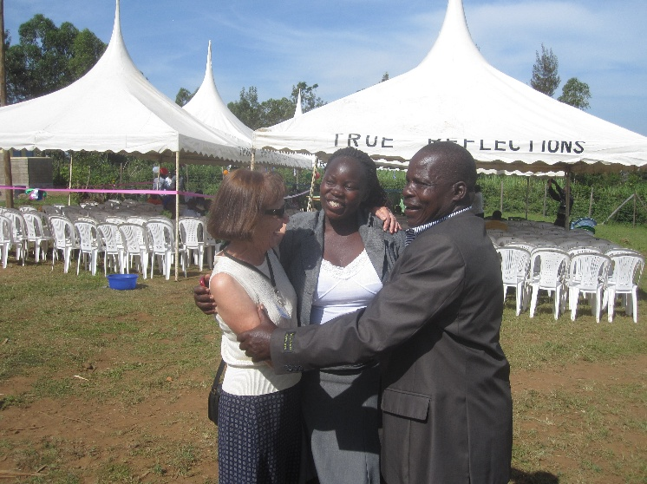
The School Opening with Joseph and Lilly Ouma

The Opening of Phase 1 included three classrooms, an administrative office, toilet blocks and a well. Construction of these first three classrooms and facilities was shared with A Better World Canada coordinated by Keith Clouten.
Phase 2 (2014) and Phase 3 (2015) included four more classrooms and a dormitory for 90 orphans.
Each year more buildings have been added, so that by 2025 the school has eight classrooms, an Early Childhood Education cottage, teachers’ cottage, dining hall with a new kitchen. A deep well was dug with the support of Maranatha International. The school acquired a house with land and leases an additional acreage each year.
On a nearby site the Vocational School offers orphans and disadvantaged children opportunities to learn work skills. These include bicycle repairs, carpentry, agriculture, tent-making, sewing, quilting and cooking.

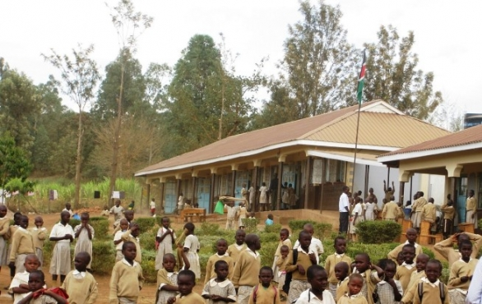
Phase 3, 2015

The student enrollment is 400 and more than 20% of the children are total orphans. The initial class of Grade 8 students sat the national Kenya Certificate of Primary Education (KCPE) examination in November 2016. The Rapogi Lwanda primary school has achieved high success each year at these examinations. Students have performed well in academics and in national choir competitions. There is a spiritual focus and an emphasis on good citizenship at the school. Some students have received financial assistance to attend high school and university; others learn skills at the Vocational School or in the gardens.
Three success stories of total orphans can be mentioned. Two have graduated from university programs, one in community nursing, the other from music theory and performance. The third will complete the Bachelor of Economics this year.
Funds are sent to Kenya for the humanitarian needs of orphans and disadvantaged children as well as to assist the teachers. Donations toward building projects and infrastructure have benefitted from tax-exemption as a registered charity in Australia, very dollar donated to these accounts has gone to Kenya with no overheads. Any differences in money transfer and risks have been met by committee members.
Lilly Ouma was forced to leave Kenya because of her leadership against the practice of Female Genital Mutilation (FGM) in a nearby area of Kenya. Her brother, Wycliffe, immediately stepped into the leadership role at the Rapogi Lwanda school. He and his wife Sharline left Kenya to gain employment in Canada and they regularly send funds to support the school. With the leadership of Wycliffe the Community-based Organization (CBO) has done well in focusing on sustainability and maintenance. The Australian committee continues to support the local Rapogi leadership on the path to full sustainability.

The members of the local Community-based Organization (CBO) take seriously the role of owning projects. Several sustainability projects have been implemented. The profits of these projects assist in paying teacher salaries. The CBO plants maize, beans and other vegetables twice each year just prior to the rainy seasons. The harvest provides food for storage and for sale to the surrounding communities.

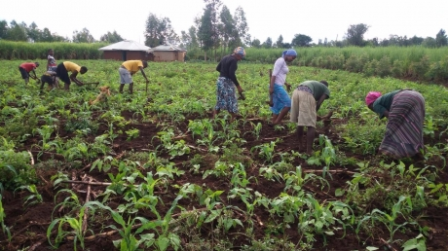
School agriculture

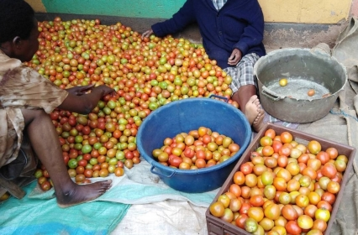
Tomatoes

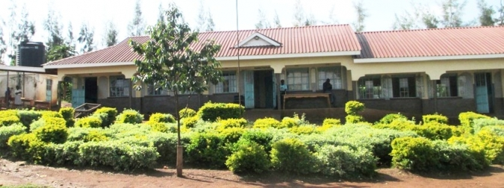
The School with landscape
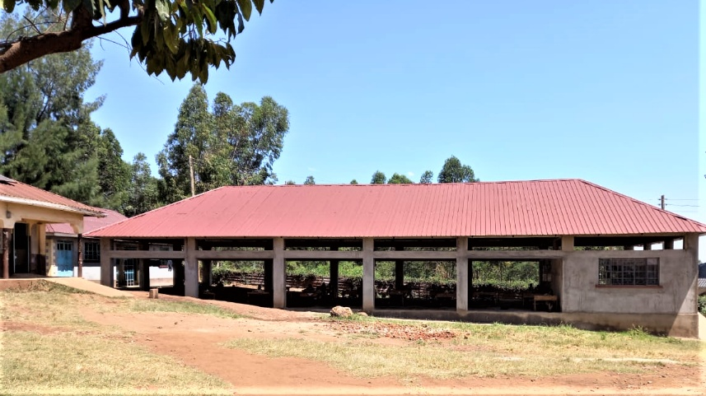
Dining Hall

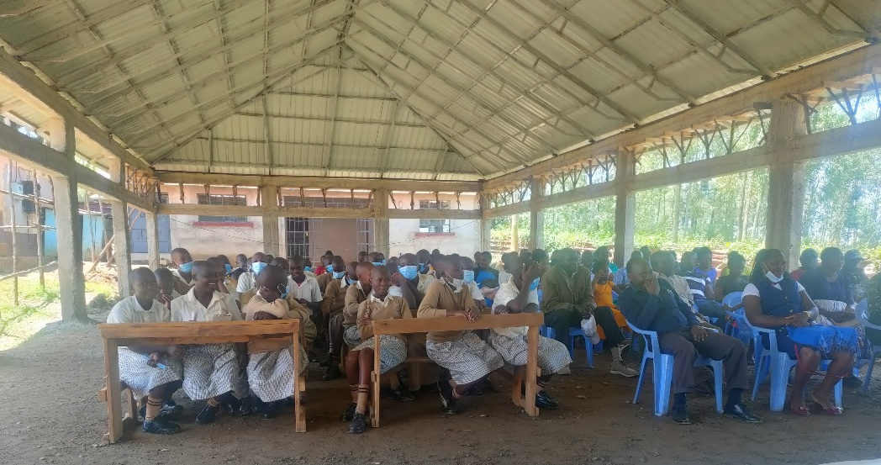
Interior of Dining Hall
You are invited to donate to the Rapogi Lwanda School for Orphans. A bank account Rapogi BSB 112-879 Account # 474 688 249 provides humanitarian aid including medical supplies, textbooks, uniform materials and for emergencies. Please contact us at the end of this website for more information. Your donation will be acknowledged and receipted by email.
The Rapogi Lwanda school and community join us in thanking you for your interest and investment in the lives of orphans and disadvantaged children.

In January 2013 at the Opening of Phase 1 of the Rapogi Lwanda School for Orphans a tree was planted by the local community. It continued to grow. During a major drought the community with our “Kenyan daughter” Faith watered the tree. The April 2025 photograph shows the tree as a symbol of wellness - true also for the school.

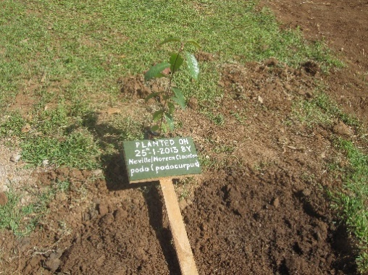
The tree planted in January 2013

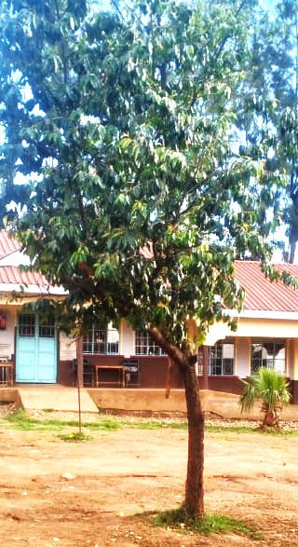
The tree today

